Warsaw, 16 March, 2022
The guidelines of the Chief Veterinary Officer on temporary procedures for non-compliant dogs/cats/ferrets accompanying refugees from Ukraine and entering Poland in the number of more than 5 animals.

- The procedure applies to owners/holders of dogs, cats or ferrets (companion animals) coming to Poland from Ukraine during the armed conflict, and these animals are their property.

- Entry with accompanying animals may only take place through a border crossing point with an approved veterinary border control post (BCP): in Dorohusk, Lubelskie region or in Korczowa in Podkarpacie region (in the above-mentioned units there is a person to contact by phone during night hours), after prior agreement on the place of isolation of the imported animals with the locally competent District Veterinary Officer.

- Notification for control is made, at least one working day before arrival at the border crossing point, by the owner of the animals, an authorised customs agency or a person representing the owner of the animals who is established in the EU (this may also be a person representing animal breeders' clubs/associations/associations in PL).

The holder/owner of companion animals declares the animals to the border veterinary officer for control by means of a completed and signed Part I of the CHEDA document (attached). This declaration means that the person responsible is obliged to cover all the costs of the control and enforcement of the decision, and to bear the consequences of failing to bring the animals to the isolation point indicated by the District Veterinary Officer.

- The place of isolation for the entire consignment of animals must be in Poland, and the exact address must be indicated in the decision of the District Veterinary Officer specifying the conditions for isolation. The isolation decision must be submitted to the Border Veterinary Officer at the latest during the inspection.
The place of isolation must concern the entire consignment of animals and may not be an animal shelter in the meaning of the Act of 21 August 1997 on animal protection.
In exceptional cases where there is no decision on isolation during the inspection, the animals may be temporarily detained under the supervision of the Border Veterinary Officer until the decision is delivered.
In this case the owner/holder of the animals should indicate the place of isolation.
The Border Veterinary Officer may ask the territorially competent DVO to grant or refuse isolation at the place indicated.

- The identity of the animals is verified on the basis of available supporting documents, including dog / cat / ferret passports or pedigree documents or other documents proving the legal ownership of the animals.

- The veterinary control on the imported animals is carried out in accordance with the standard procedure for veterinary border control of animals.

- If the District Veterinary Officer responsible for the proposed place of isolation refuses to authorise it, the border control has negative result and the animals are returned outside the EU.

- If the holder/owner of the animals presents the agreement of the territorially competent DVO to carry out the isolation referred to in point 4 and during the border control the Border Veterinary Officer finds that the import requirements for the consignment of animals are not met, Article 66 of Regulation (EU) 2017/625 applies, i.e. the animals are directed to the indicated place of isolation until a final decision is taken by the Border Veterinary Officer.

- The document confirming the control (CHEDA) will not be validated (remains "pending") until the isolation of the animals has been completed and the Border Veterinary Officer has received feedback from the District Veterinary Officer supervising the isolation confirming the compliance of the isolated animals.
- Isolation of animals includes the time needed to carry out procedures required by law, such as:
-being microchipped;
-vaccination against rabies of animals over 12 weeks of age (for younger animals, vaccination may start at 8 weeks of age);
-titration of rabies antibody levels in vaccinated animals 30 days after vaccination.
The test for rabies antibodies will only be performed in laboratories authorised for that purpose:
https://ec.europa.eu/food/animals/movement-pets/approved-rabies-serology-laboratories/approved-rabies-serology-laboratories-eu-countries_en

- Once information about completion of the isolation and confirmation of compliance is received, the CHEDA document is approved with a positive decision.

CHEDA - TEMPLATE
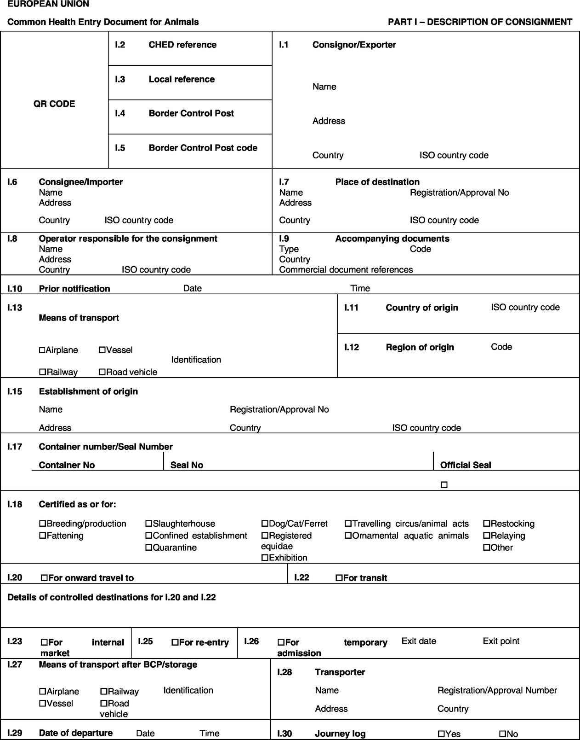

E.g. Civil law agreements entered into before 24.02.2022, electronic registration for exhibitions (breeding dogs are microchipped), proof that the animal has taken part in an exhibition - catalogues, evaluation cards with the transponder number or photos of evaluation cards, breeder's websites with the animal's details, results of laboratory or clinical tests.
Compulsory anti-rabies vaccination after 12 weeks of age, or in the case of an unsatisfactory result in the rabies antibody test (less than 0.5 IU/ml)

